HOME GROWN WRESTLING CLUB
GLADIATOR 2 DAY WRESTLING CAMP K-12
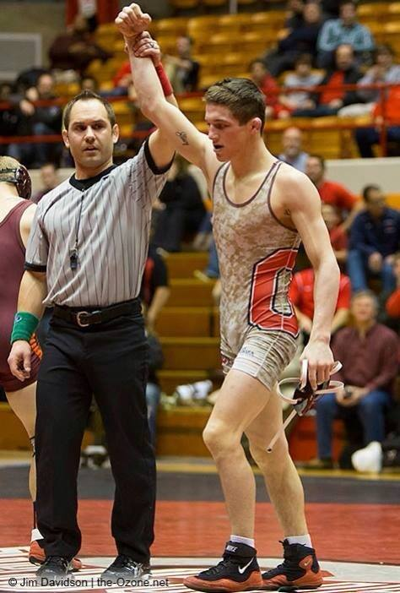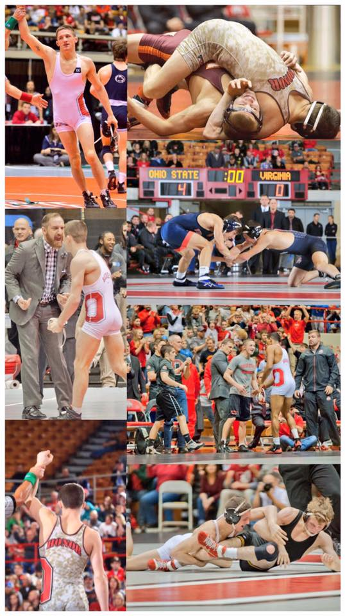

CLINICIANS:
BRANDON REED LINDSEY WILSON / OHIO STATE JOHNNI DIJULIUS
4X NAIA ALL AMERICAN 175-11 OHIO HIGH SCHOOL CAREER RECORD
3X NAIA NATIONAL CHAMPION 3X OHIO STATE HIGH SCHOOL STATE CHAMPION
4X MID-SOUTH CONFERENCE 1ST TEAM 1X OHIO STATE HIGH SCHOOL RUNNER-UP
2021 NAIA WRESTLER OF THE YEAR 4 YR OHIO STATE BUCKEYE WRESTLER
2021 NAIA OUTSTANDING WRESTLER 4X NCAA NATIONAL QUALIFIER
NAIA WRESTLER OF THE WEEK 4TH PLACE BIG 10 CHAMPIONSHIPS
LINDSEY WILSON COLLEGE GRAD ASSISTANT OVER 100 OHIO STATE BUCKEYE WINS
EASTERN MICHIGAN OPEN CHAMPION
CLIFF KEEN LAS VEGAS INVITATION CHAMPION
NUMEROUS BIG 10 WRESTLER OF THE WEEK
FORMER KENT STATE ASSISTANT COACH
WHEN:
SATURDAY JUNE 26, 2021 & SUNDAY JUNE 27, 2021
WHERE:
(INSIDE TOWNE MALL NEXT TO JC PENNY AND ACROSS FROM TWELVE NINJA GYM)
1704 N. DIXIE HIGHWAY SUITE# C001 ELIZABETHTOWN KY 42701
LIMITED TO 1ST 30 PREPAID WRESTLERS
http://home-grown-wrestling-club-llc.square.site/
https://account.venmo.com/u/Home_Grown_Wrestling_Club
SESSIONS: COST:
9AM-12PM SESSION 1 $150 FOR BOTH DAYS 6 SESSIONS
^{12PM-1PM ( LUNCH )}
1PM-4PM SESSION 2 ( LUNCH IS NOT PROVIDED )
^{4:30PM-5:30PM SESSION 3}
EQUIPMENT NEEDED:
WRESTLING SHOES, HEAD GEAR (OPTIONAL), WATER, SHORTS OR SWEATS & T-SHIRT AND FOOD AND SNACKS.
SPECIAL GUEST ASSISTANT COACHES
DERRICK SMALLWOOD LINDSEY WILSON COLLEGE WRESTLING
COREY KNOTH BELLARMINE UNIVERSITY WRESTLING
HAVE QUESTIONS? NEED MORE INFORMATION?
CONTACT: HOMEGROWNWRESTLINGCLUB@YAHOO.COM OR CALL
WILLIAM KNOTH 270-945-0635

